Recent publications by KMU Akademie DBA graduates (and staff)

1.
Udo Leicht graduated with a KMU DBA in February 2022 and published his thesis with Springer in November 2022 (English translation of the title: Success Factors of Supply Chain Risk Management in Times of Crisis. An Empirical Analysis of Small and Medium B2C Enterprises in Germany using the Example of the Covid-19 Pandemic).

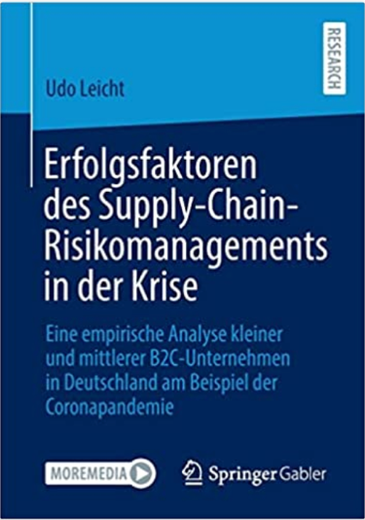

https://link.springer.com/book/10.1007/978-3-658-39505-6

2.
The following recent KMU Akademie DBA graduates have published their research together with KMU lecturer and advisor, Thomas Angerer, in an edited book which appeared at Springer Verlag in late December 2022:

Manuel Beck
Juri Behler
Volker Eickenberg
Johannes Eigner
Pierre Stern

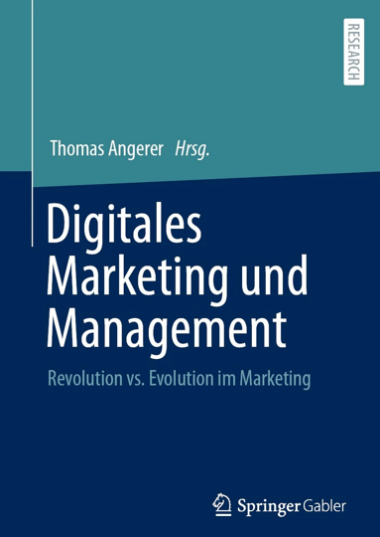

https://www.amazon.de/Digitales-Marketing-Management-Revolution-Evolution/dp/3658380039?asin=3658380039&revisionId=&format=4&depth=1

3.
A further edited book (English translation of the title: Management Research. Management in Times of Radical Change) will come out in June 2023 with articles by seven KMU Akademie DBA graduates. The book is edited by two KMU Akademie colleagues, Thomas Angerer and Andrea Rögner, who is also the KMU Akademie DBA programme leader.

The following KMU Akademie DBA graduates have contributed articles:

Manuel Beck
Juri Behler
Volker Eickenberg*
Johannes Eigner
Heinz Hähnel
Jennifer Friedrich-Haßauer
Pierre Stern

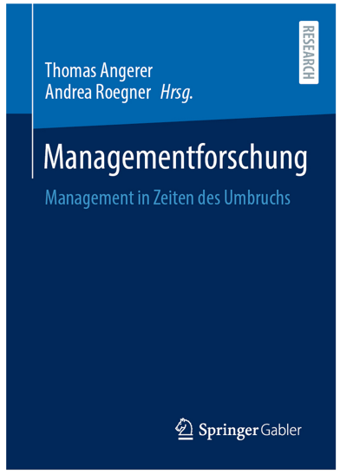

*) Volker Eickenberg had his thesis published by Peter Lang in 2020 (English translation of the title: Trust in Insurance Distribution. An Empirical Analysis of Customer Expectations on the Behaviour of Insurance Representatives in Face-to-Face Interaction):

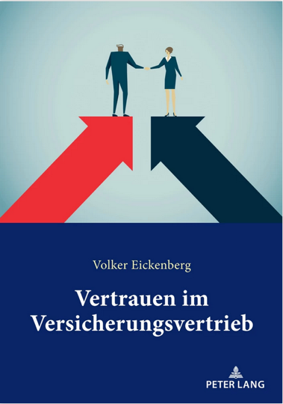

https://www.peterlang.com/document/1059255#

